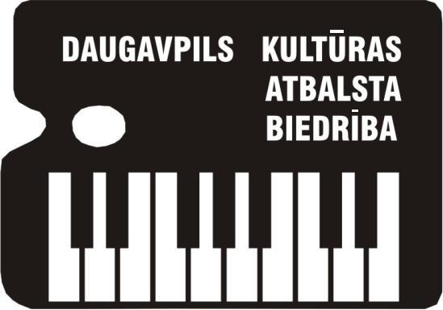
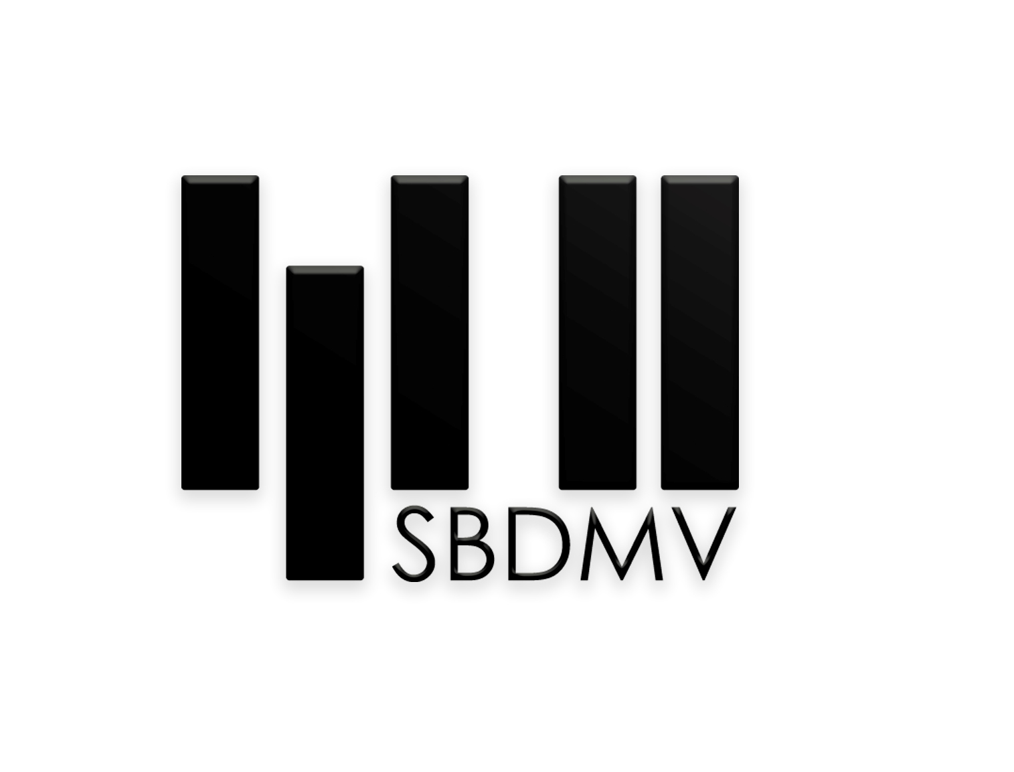

VIII International Chamber Ensembles Competition
NOVA MUSICA
REGULATIONS

The Society of Cultural Support of Daugavpils and Stanislavs Broks Daugavpils Music Secondary school in collaboration with the Ministry of Culture of the Republic of Latvian, the Culture Capital Foundation of Latvia, Daugavpils City Council organizes the VII International Chamber Ensembles Competition NOVA MUSICA.

The aims and goals of the contest
- To popularize chamber music composed for the period of the last 100 years;
- To promote performing chamber instrumental music by Latvian composers;
- To stimulate and promote creative activity of young composers in the sphere of chamber ensembles, piano duets and Latvian folk music treatment;
- To focus teachers and students’ attention on the variety of trends and styles in works of art of XX and XXI centuries;
- To diversify pedagogical and concert repertoire;
- To find out and support the most talented music performers;
- To establish contacts between students and teachers, as well as between educational establishments of West and East.

Time and place
The contest will be held on 30 November - 1 December, 2017, in Staņislavs Broks Daugavpils Music Secondary School.
The address: Kandavas iela 2A, Daugavpils, LV-5401, Latvia, phone (+371) 5407900, email sbdmv@sbdmv.lv

Participants
Different acoustic chamber ensembles with piano (from 3 up to 9 members), as well as piano ensembles (4, 6, 8 hands) can take part in the contest. During the performance the players’ complement cannot be changed.
The contest will be held according to four age groups:
A up to 10 years of age
B up to 13 years of age
C up to 16 years of age
D up to 20 years of age

Programme
The competition has one round. Each ensemble should play two pieces, composed in the period of 1917 – 2017:

* A composition, a cycle, or its part (parts) by a composer from the represented participant’s country;
* A composition, a cycle, or its part (parts), neither by a Latvian composer, nor by a composer from the participant’s country.
Only original works must be included in the programme of piano duets. As for other chamber ensembles, as well as piano ensembles for 6-8 hands, they are allowed to use adapted pieces; in this case the author of the changes should be mentioned. The notes of adapted and treated pieces are to be submitted to the managing committee on arrival at the contest.
After having been put in the application, the programme cannot be changed.
Participants are allowed to use their notes during the performance.
Programme timing without a compulsory composition:
Group A 4-7 min
Group B 6-9 min
Group C 8-11 min
Group D 10-14 min
The order of performing will be determined by drawing the lots.

Assessment
The contest will be assessed by an international jury. The students of the members of jury cannot participate in the competition. The participants will be marked after a 25-point system. The decision of the jury is final and is not to be reconsidered.

Awarding
The winners of the contest will be given diplomas of degrees I, II, III, as well as prizes.
In addition, the following prizes will be given:
- For the best performance of a foreign composer’s work;
- For the best performance of a national composer’s work;
Special awards and premiums can be given by juridical and physical persons, as well as by public organizations.
Contest auditions are held openly. The laureates of the contest perform in the final concert free of charge. The managing committee has the right to broadcast the contest on the radio, on television, to do audio and video records, to distribute the records in non-commercial aims without paying fees.

Application
The participants should send out the following documents:
- application form (the form is enclosed);
- creative biography;
- photo (good quality of JPG format);
- a copy of a document on payment to the bank account.
The application form should be sent to an email sbdmv@sbdmv.lv) before 10 November, 2017. When registering on the day of the contest, contestants are required to present personal identification document.

Participation fee is 20 euro; it is to be sent to the following account by 10 November, 2017:
Stanislavs Broks Daugavpils Mūzikas vidusskola, Kandavas iela 2A, Daugavpils, LV- 5401, Latvija,
Reg.Nr.90000066001
Current account LV04TREL2220521005000
VALSTS KASE , bank code TRELLV22
Kameransambļu konkursam.
Participation fee can be paid on arrival at the contest.

Travel and accommodation expanses are covered by participants.

Application form
Ensemble’s name, complement | Names, surnames of the ensemble’s members, telephone number, email, instrument | Dates of birth | Age group | Country, town, school, school address, telephone number, email | Teacher’s name, surname, telephone number, email | Programme | Timing

